Business Calculations

Calculation of the selling price (15 points)

Mr. Arberg and Mr. Zucker have developed a site specializing in the sale of computer and high-tech equipment. They would like to put this virtual reality headset on sale.

The site is a company created last year. Its turnover was 90’000 francs. They expect a 40% increase in sales for this year.

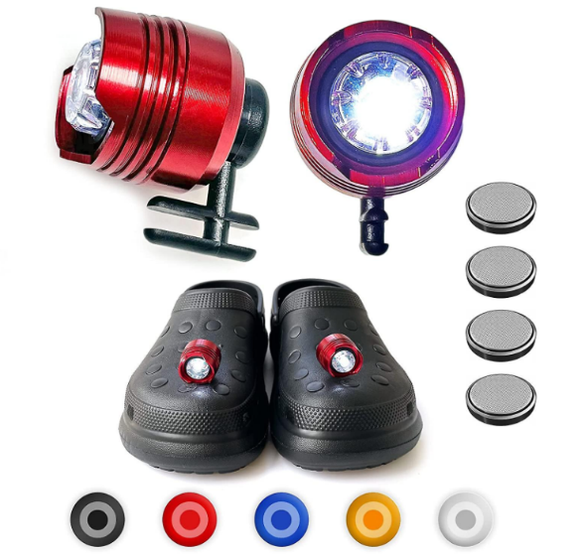
A new trendy trend is croc accessorizing as shown in this image. The two friends would like to put this item up for sale on their website.

To do this, they contact the company "My Tech Furies" in Belgium. This company, based in Chatelet, offers a wide choice of multimedia items of the highest quality: a whole range of devices and accessories, from the smallest electronic gadget to consoles not found in our supermarkets. Tireless geeks, this Belgian firm roams the good deals to offer the nuggets and best deals on the Web.

The pair of croc headlights is available for € 1.53 incl. VAT. It is planned to order 1’000 units to start the business. The negotiations resulted in a 20% professional discount and € 0.05 discount per unit for proforma payment. Transport is provided by a Belgian company which charges € 120.— for the lot.

Additional information:

- the Belgian VAT rate is 21%;
- the mark up rate for operating expenses is 75%;
- the mark up rate of the net margin is 225%;
- the card fee rate is 2.5%;
- The exchange rate of foreign currencies is based on the following table:

It is better to make the calculations for the 1’000 units and divide the total by the number of units at the end, it will help being more accurate.

Determine the sale price of this item to be displayed online.

Calculation :

