Chap. 3: Problems and Applications
Solutions 7. & 8.

- a. As Figure 1 shows, in both markets the increase in demand increases both the
equilibrium price and the equilibrium quantity.

- In the market for seafront properties, with price inelastic supply, the increase in demand leads to a larger increase in the price than is the case in the market for cars.

- In the market for cars, with price elastic supply, the increase in demand leads to a larger increase in quantity than is the case in the market for seafront properties.

- In both markets, total consumer spending rises, since both equilibrium price and equilibrium quantity rise.

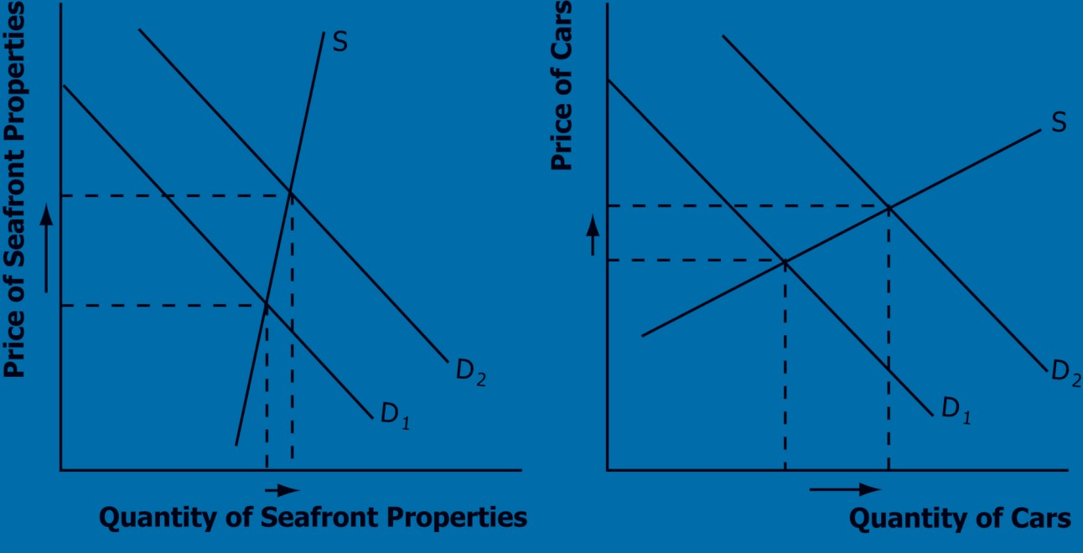

Figure 1

- a. For business travellers, the price elasticity of demand when the price of tickets rises from
€200 to €250 is [(2,000 - 1,900)/1,950]/[(250 - 200)/225] = 0.05/0.22 = 0.23. For
holidaymakers, the price elasticity of demand when the price of tickets rises from €200 to
€250 is [(800 - 600)/700] / [(250 - 200)/225] = 0.29/0.22 = 1.32.

b. The price elasticity of demand for holidaymakers is higher than the elasticity for business travellers because holidaymakers can more easily choose a different mode of transportation (like driving or taking the train) or choose to take a holiday in the UK rather than Italy. Business travellers are less likely to change their mode of travel since time is more important to them and their schedules are less adaptable. Nor are they so likely to simply not visit Naples.

