Chap. 3: Problems and Applications
Solutions 1., 2., 3. & 4.

- a. Drought damages the soft fruits, reducing the supply of soft fruits. This can be seen in Figure 1 as a shift to the left in the supply curve for soft fruits. The new equilibrium price is higher than the old equilibrium price.

Figure 1

- The report will lead to a reduction in the amount people wish to buy of the product at each and every price. This is represented by a shift in the demand curve to the left and a resultant new lower equilibrium price as shown in Figure 2.

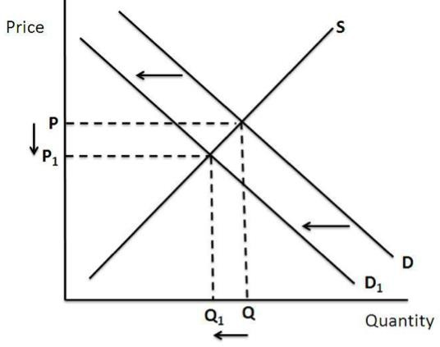

Figure 2

- When the United States announces that it intends to impose new sanctions on the Islamic Republic of Iran, many markets are affected. Since much oil production takes place there, the sanctions disrupt oil supplies, shifting the supply curve for petrol to the left, as shown in Figure 3. The result is a rise in the equilibrium price of petrol. With a higher price for petrol, the cost of operating a petrol-guzzling car, like a Mercedes, will increase. As a result, the demand for used Mercedes will decline, as people in the market for cars will not find Mercedes as attractive as before. In addition, some people who already own Mercedes will try to sell them. The result is that the demand curve for used Mercedes shifts to the left, while the supply curve shifts to the right, as shown in Figure 4. The result is a decline in the equilibrium price of used Mercedes.

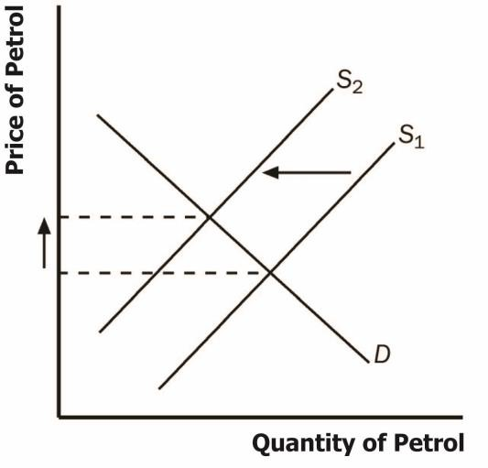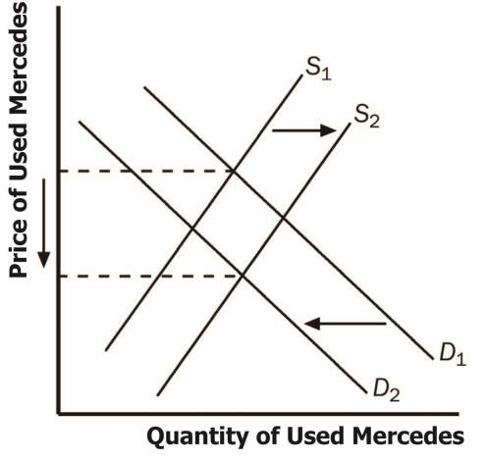

Figure 3 Figure 4

- a. When a drought in Egypt damages the cotton crop, it raises input prices for producing sweatshirts. As a result, the supply of sweatshirts shifts to the left, as shown in Figure
5. The new equilibrium has a higher price and lower quantity of sweatshirts.

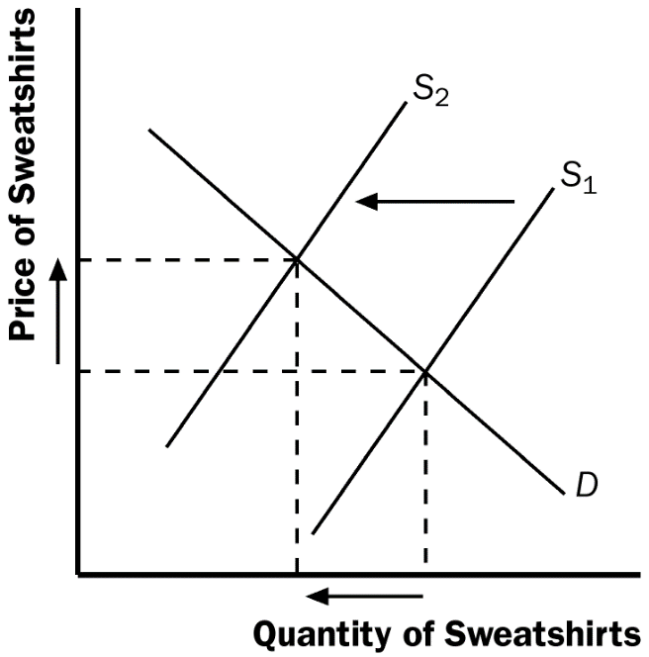

Figure 5

- A decline in the price of leather jackets leads more people to buy leather jackets, reducing the demand for sweatshirts (on the assumption that sweatshirts and leather jackets are substitutes for one another). The result, shown in Figure 6, is a decline in both the equilibrium price and quantity of sweatshirts.

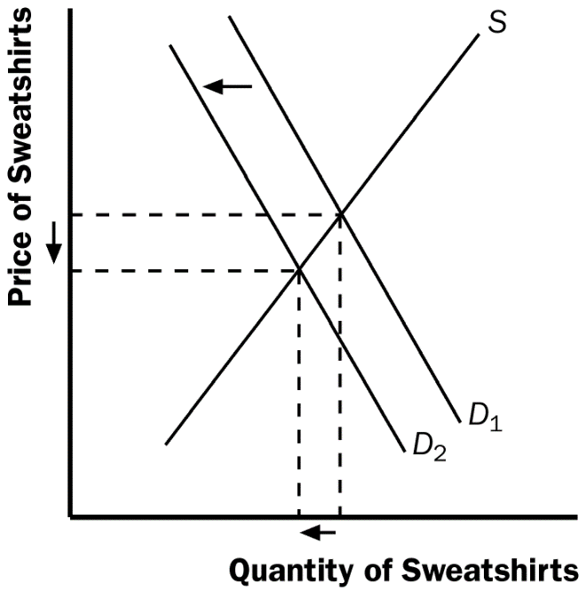

Figure 6

- The effect of universities requiring students to engage in morning exercise classes in appropriate attire is to raise the demand for sweatshirts, as shown in Figure 7. The result is an increase in both the equilibrium price and quantity of sweatshirts.

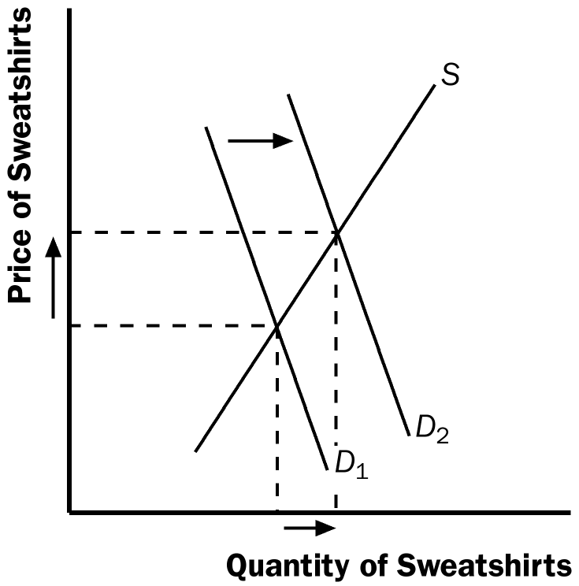

Figure 7

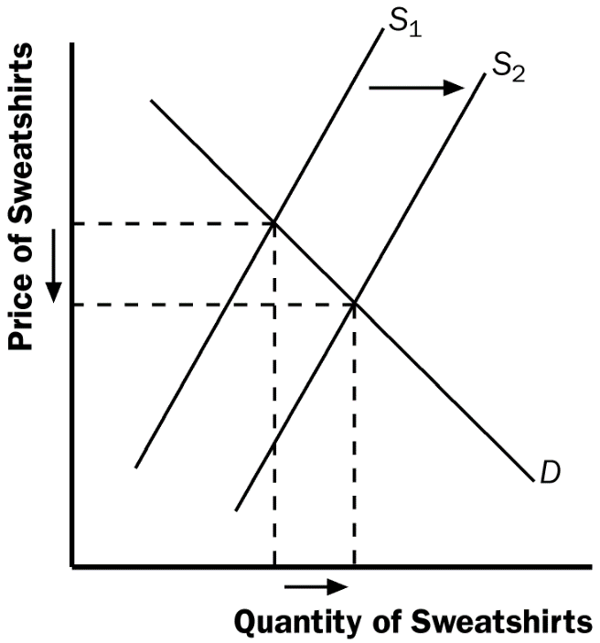
- The invention of new knitting machines increases the supply of sweatshirts. As Figure 8 shows, the result is a reduction in the equilibrium price and an increase in the equilibrium quantity of sweatshirts.

Figure 8

- a. Cigars are substitutes for cigarettes, since a higher price for cigarettes would increase the demand for cigars.

- An increase in the tax on cigarettes leads to increased demand for cigars. The result, as shown in Figure 9 for cigars, is a rise in both the equilibrium price and quantity of cigars.

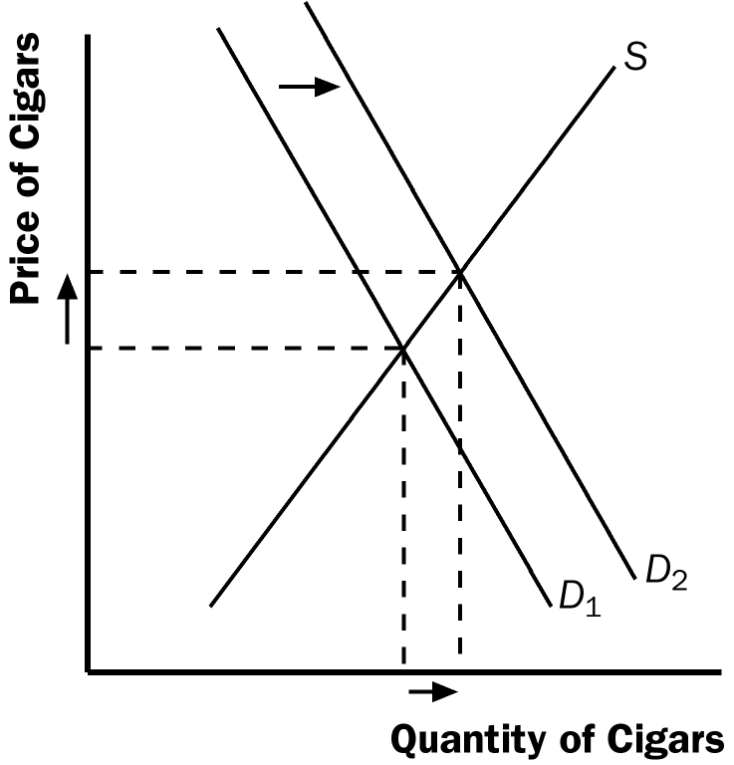

Figure 9

- The results in part (b) showed that a tax on cigarettes leads people to substitute cigars for cigarettes when the tax on cigarettes rises. To reduce total tobacco usage, policymakers might also want to increase the tax on cigars.

- Spain is a major supplier of oranges. Producers' use of new fertilizer leads to a shift in the supply of oranges at each given price. The news from scientists that eating oranges is good for health leads to a change in consumer tastes. Consumers demand more at each given price. The demand curve shifts outwards. In the example shown in Figure 10 below prices have fallen a little and the quantity demanded has risen significantly. If the supply had only increased a small amount, then prices could have risen.
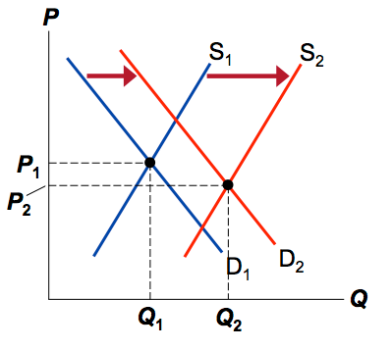

Figure 10

