Finance Module – Commercial price

Calculation of the selling price
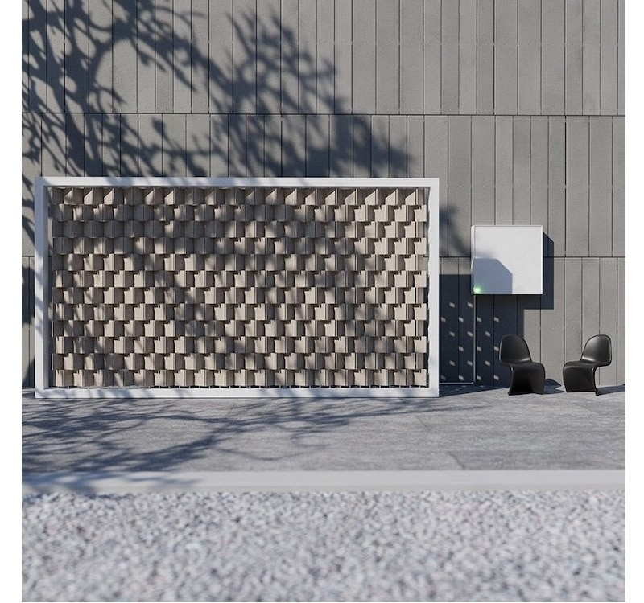
T solar panels are a good source of renewable energy for homes, but an even more efficient and cost-effective method is often overlooked — wind power. Harnessing wind is an incredibly powerful way to create energy, but wind power comes to mind primarily in terms of large turbines installed in the ocean or in open fields. Designer Joe Doucet seeks to help homeowners become energy savers while adding a touch of beauty to their homes. Its Wind Turbine Hall serves as both a kinetic sculpture and a wind wall.

The company SolAlpes SA has decided to market them. It will work with an importer based in Basel. The prices indicated do not correspond to reality because this product is not yet marketed.

The purchase price is Fr. 800.— excluding VAT. The importer grants him a professional discount of 10%. Delivery costs are 15% of the net purchase price and are charged by the importer.

- What is the amount charged by the importer (swiss supplier including VAT) for the acquisition of a wind wall?

For installation and delivery to the customer, the following must considered:

- Delivery package and Installation at the customers place is 250 CHF.
- Operating costs are calculated with a mark-up rate of 190% on the purchase price.
- Net margin is 25% of the sale price.

- What will be the final quote to send to a customer for the complete installation of a wind wall?

